**LEASE MANAGEMENT**

**Introduction:** Are you new to Salesforce? Not sure exactly what it is, or how to use it? Don’t know where you should start on your learning journey? If you’ve answered yes to any of these questions, then you’re in the right place. This module is for you.

Welcome to Salesforce! Salesforce is game-changing technology, within a host of productivity-boosting features, that will help you sell smarter and faster. As you work toward your badge for this module, we’ll take you through these features and answer the question, “What is Salesforce, anyway?

**What Is Salesforce?**

Salesforce is your customer success platform, designed to help you sell, service, market, analyze, and connect with your customers.

Salesforce has everything you need to run your business from anywhere. Using standard products and features, you can manage relationships with prospects and customers, collaborate and engage with employees and partners, and store your data securely in the cloud.

So what does that really mean? Well, before   Salesforce, your contacts, emails, follow-up tasks, and prospective deals might have been organized something like this:

<https://youtu.be/r9EX3lGde5k>

**Milestone-1**

**Salesforce Account**

### Activity – 1 Creating Developer Account:

Creating a developer org in salesforce.

1. Go to <https://developer.salesforce.com/signup>
2. On the sign-up form, enter the following details:

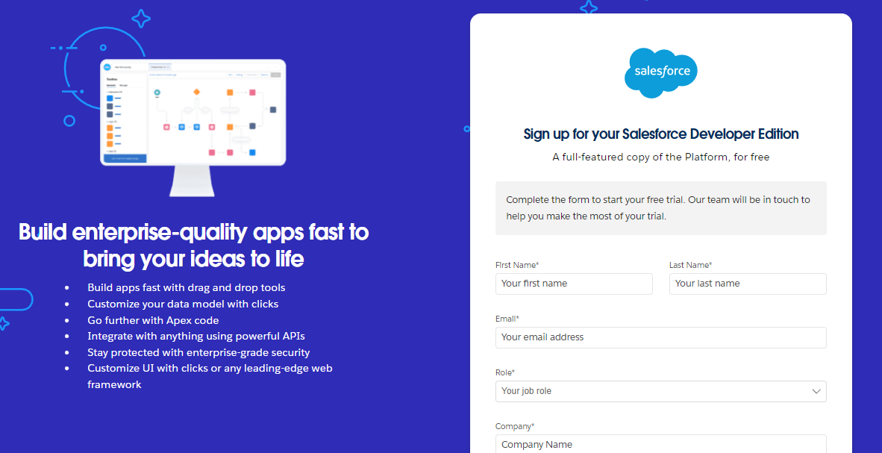

**First Name :** KOTAKONDA

**Last Name :** RENUKA

**Email**  : kotakondarenukasuren05@gmail.com

**Role :** Developer

**Company :** Gayatri Degree College Tirupati

**Country :** India

**Activity 2: Account Activation:**

**Account Activation:**

1. Go to the inbox of the email that you used while signing up. Click on the verify account to activate your account. The email may take 5-10mins.

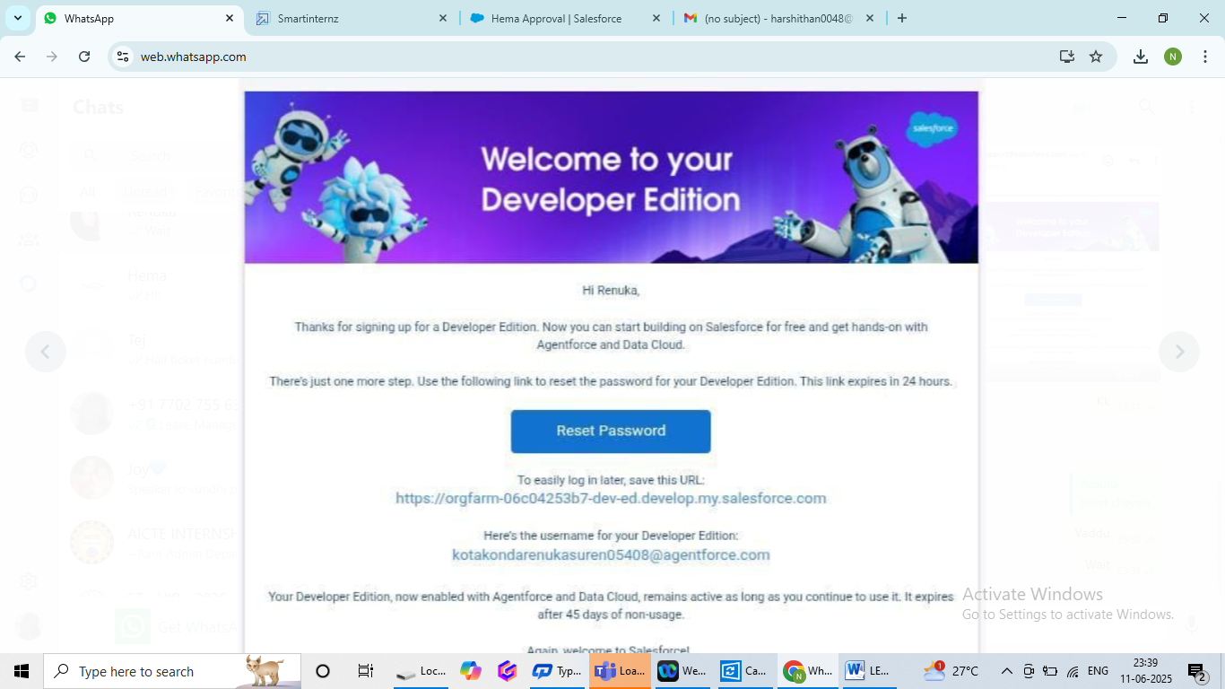

1. Click on Verify Account
2. Give a password and answer a security question and click on change password.

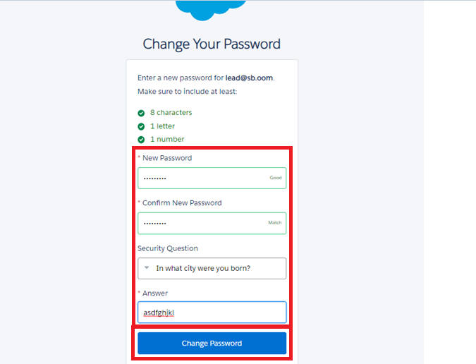

1. Then you will redirect to your salesforce setup page.

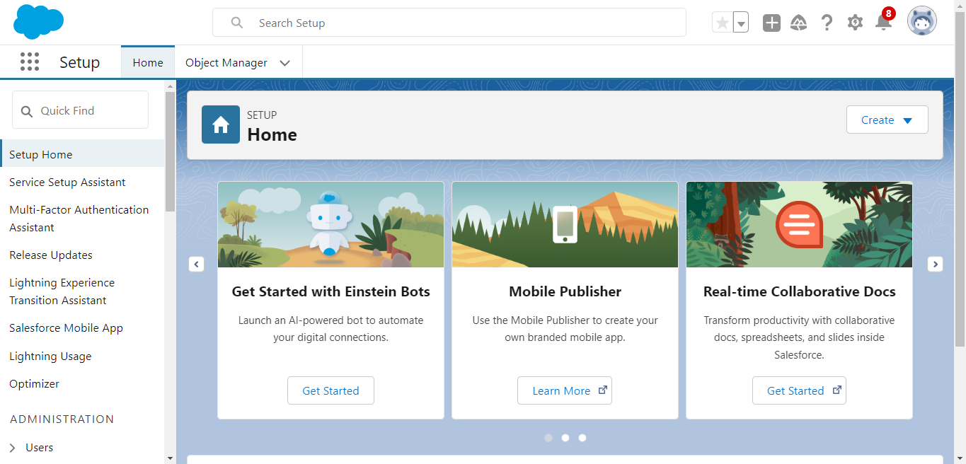

|  |  |  |
| --- | --- | --- |
| https://ci3.googleusercontent.com/meips/ADKq_NZYfeL-lGd40vlCb37qVw2duJBA-LeVYfcLxAjCoEflVbAefkUKiiFw44_2rSdsIysQb828h4kmPXWP_rzOqUKcMulUXbpJo47hTEAb-AcGdebRVrE=s0-d-e1-ft#https://can96.sfdc-58ktaz.salesforce.com/img/welcomeEmail/p.gif | https://ci3.googleusercontent.com/meips/ADKq_NZYfeL-lGd40vlCb37qVw2duJBA-LeVYfcLxAjCoEflVbAefkUKiiFw44_2rSdsIysQb828h4kmPXWP_rzOqUKcMulUXbpJo47hTEAb-AcGdebRVrE=s0-d-e1-ft#https://can96.sfdc-58ktaz.salesforce.com/img/welcomeEmail/p.gif | https://ci3.googleusercontent.com/meips/ADKq_NZYfeL-lGd40vlCb37qVw2duJBA-LeVYfcLxAjCoEflVbAefkUKiiFw44_2rSdsIysQb828h4kmPXWP_rzOqUKcMulUXbpJo47hTEAb-AcGdebRVrE=s0-d-e1-ft#https://can96.sfdc-58ktaz.salesforce.com/img/welcomeEmail/p.gif |

**Milestone-2**

**Object Creation**

**Activity – 1: Create Property Object:**

To Navigate to Setup page:

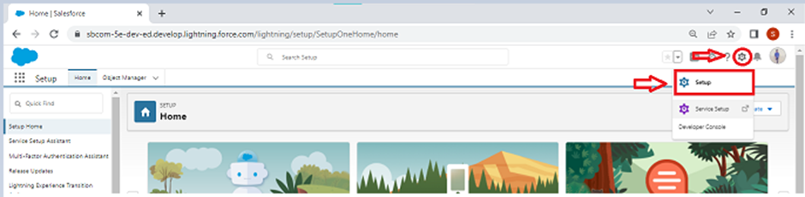

To create an object:

1. From the setup page? Click on Object Manager? Click on Create? Click on Custom Object.

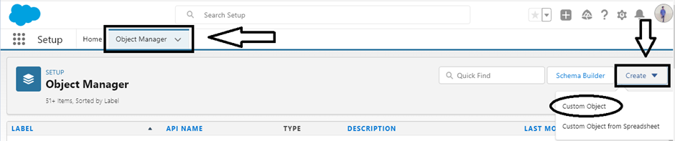

2. Enter label name as property

3.Enter plural label name as property

4.EnterRecordName as property name

5.Select data type as Text

6.Select Allow reports, Track field history, Allow activities

8.Click on Save and New

### 

### 

### Activity – 2 Create Tenant Object:

### From set up page

1. Click on Object Manager

### 2. Click on Create>>Click on Custom Object

### 3. Enter label name as Tenant

### 4. Enter plural label name as Tenants

### 

### 5. Enter record name as Tenant Name

### 6. Enter data type as Text

### 7. Click on Allow reports, Track field history, Allow activities

### 8. Click on Allow search

### 

### 9. Click on Save and New

### 

### Activity - 3 Create Payment Object:

### From set up page

### 1. Click on Object Manager

### 2. Click on Create>>Click on Custom Object

### 3. Enter label name as Payment for tenant

### 4. Enter plural label name as Payment

### 

### 5. Enter record name as Payment Name

### 6. Enter data type as Text

### 7. Click on Allow reports, Track field history, Allow activities

### 

### 8. Click on Allow Search

### 9. Click on Save And New

### 

### Activity – 4 Create Lease Object:

### From set up page

### 1. Click on Object Manager

### 2. Click on Create>>Click on Custom Object

### 3. Enter label name as lease

### 4. Enter plural label name as lease

### 

### 5. Enter record name as lease Name

### 6. Enter data type as Text

### 7. Click on Allow reports, Track field history, Allow activities

### 

### 8. Click on Allow search

### 9. Click on Save and New

### 

### Milestone-3

### Tab Creation

### Activity - 1 To create a Tab:( Property)

### From set up page

### 1.Search for Tabs in the Quick find box

### 2.Click on tabs

### 3.Click on New under custom object tab

### 4.Select object Property >>Select the tab style

### 

### 5. Click on next>> (Add to profile page) keep it as default>>Click on Next (Add to custom app) Uncheck the include tab.

### 6. Make sure that the Append to tab user’s existing personal customizations is checked

### 7. Click on Save

### Activity – 2 To create a Tab:( Tenant)

### From set up page

### 1. Search for Tabs in the Quick find box

### 2. Click on tabs

### 3. Click on New under custom object tab

### 4. Select object Tenant>>Select the tab style

### 

### 5. Click on next>> (Add to profile page) keep it as default>>Click on Next (Add to custom app) Uncheck the include tab.

### 6.Make sure that the Append to tab user’s existing personal customizations is checked

### 7.Click on Save

### Activity – 3 To create a Tab:(Payment for tenants)

### From set up page

### 1. Search for Tabs in the Quick find box

### 2. Click on tabs

### 3. Click on New under custom object tab

### 4. Select object Payment for tenant>>Select the tab style

### 

### 5. Click on next>> (Add to profile page) keep it as default>>Click on Next (Add to custom app) Uncheck the include tab.

### 6.Make sure that the Append to tab user’s existing personal customizations is checked

### 7.Click on Save

### Activity – 4 To create a Tab:(lease)

### From set up page

### 1. Search for Tabs in the Quick find box

### 2. Click on tabs

### 3. Click on New under custom object tab

### 4. Select object lease>>Select the tab style

### 

### 5. Click on next>> (Add to profile page) keep it as default>>Click on Next (Add to custom app) Uncheck the include tab.

### 6. Make sure that the Append to tab user’s existing personal customizations is checked

### 7. Click on Save

### Milestone – 4

### The Lightning App

### Activity – 1 To create a lightning app page:

### From the set up

### 1.SearchAppManager in the Quick find box>>Select App Manager>>Click on New Lightning App

### 

2. Fill the app name in app details and branding as follow

App Name: Lease Management

Developer Name: This will auto populated

Image: optional (if you want to give any image you can otherwise not (mandatory)Primary colour hex value: keep this default.

3. Then click Next >> (App option page) Set Navigation Style as Standard Navigation >> Next.

(Utility Items) keep it as default >> Next.

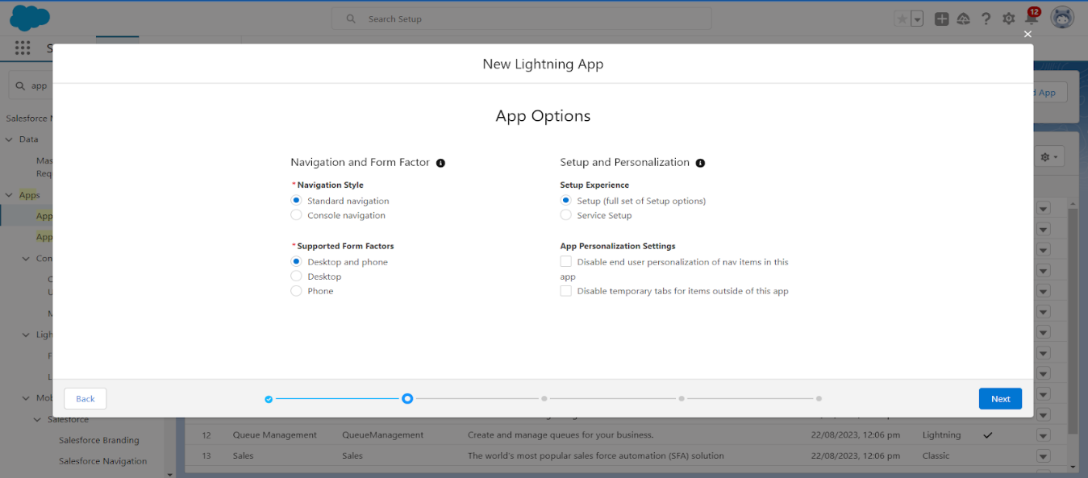

4. To Add Navigation Items:

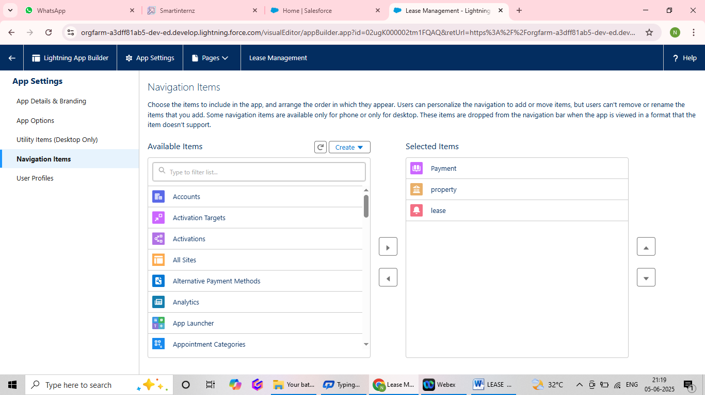

Search for the item in the (Payment for tenant, Tenants, property, lease) from the search bar and move it using the arrow button? Next? Next.

5. To Add User Profiles:

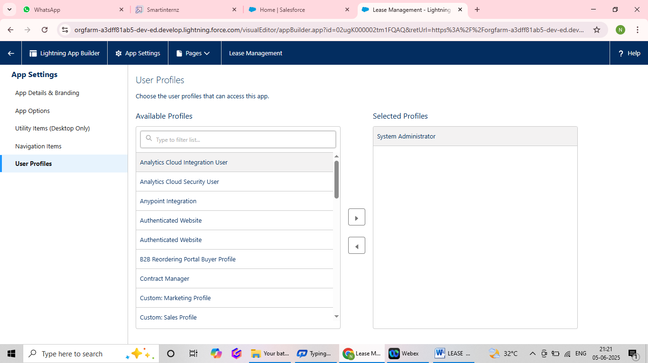

Search profiles (System administrator) in the search bar >>click on the arrow button >> save & finish.

### Milestone – 5

### Fields

### Activity – 1 To create fields in an object:

### From set up

### Click on Object Manager>>type Object name (property)in search bar>>Click on the object

### Click on Fields and Relationships>>New

### Select data type as Text

### 

### Click on next

### 

### Enter field label as Name

### Field name will be auto generated

### Length: 25

### Required: Check box

### 

### Click on Next>>Next>>Save and New

### To create another fields in an object:

### From the set up

### 1.Click on ObjectManager>>type object name(property)in search bar>>Click on the object

### 2.Click on Fields and Relationships>>New

### 3.Select Data type as a”Long Text” and click on Next

### 4.Fill the Above as following

### Field Label:Address

### Field Name:gets auto generated

### 

### Click on Next>>Next>>Save and New

### To create another fields in an object

### From the set up

### 5.Click on ObjectManager>>type object name(property)in search bar>>Click on the object

### 6.Click on Fields and Relationships>>New

### 7.Select data type as “picklist” and click on Next

### 8.Fill the above as following

### Field label:Type

### Field Name:gets auto generated

### Enter values with each value separated by a new line

### Enter these values

### 1BHK

### 2BHK

### 3BHK

### 9.Click on Next>>Next>>Save and New

### To create other fields in an object

### From the set up

### 1. Click on Object Manager>>type object name(property)in search bar>>Click on the object

### 2. Click on Fields and Relationships>>New

### 3. Select data type as “Text” and click on Next

### Fill the above as following

### Field label: sfqt

### Field Name: gets auto generated

### Length:18

### 

### 4.Click on Next>>Next>>Save

### Activity – 2 Creation of fields for the Tenant object

### To create another fields in an object

### From the set up

### 1.Click on Object Manager>>type object name(property)in search bar>>Click on the object

### 2.Click on Fields and Relationships>>New

### 3.Select data type as a “Email” and click on next

### 4.Fill the Above as following:

### Field label: Email

### Field Name: gets auto generated

### Click on required check box

### 

### 6.Click on Next>>Next>>Save and New

### To create another fields in an object

### From the set up

### 1.Click on Object Manager>>type object name(property)in search bar>>Click on the object

### 2.Click on Fields and Relationships>>New

### 3.Select data type as a “phone” and click on next

### 4.Fill the Above as Following:

### Field label: Phone

### Field Name: gets auto generated

### 

### Click on Next>>Next>>Save and New

### To create another fields in an object

### From the set up

### 1.Click on Object Manager>>type object name(property)in search bar>>Click on the object

### 2.Click on Fields and Relationships>>New

### 3.Select data type as “Picklist” and click on next

### 4.Fill the Above as Following:

### Field label: status

### Field Name: gets auto generated

### Enter values with each value separated by a new line

### Enter these values:

### Stay

### Leaving

### 

### Click on Next>>Next>>Save and New

### Activity – 3 Creation of fields for the Lease object

### To create another fields in an object

### From the set up

### 1.Click on Object Manager>>type object name(property)in search bar>>Click on the object

### 2.Click on Fields and Relationships>>New

### 3.Select data type as “Date” and click on Next

### 4.Fill the Above as Following:

### Field label: start date

### Field Name: gets auto generated

### 

### Click on Next>>Next>>Save and New

### To create another fields in an object

### From the set up

### 1.Click on Object Manager>>type object name(property)in search bar>>Click on the object

### 2.Click on Fields and Relationships>>New

### 3.Select data type as “Date” and click on Next

### 4.Fill the Above as Following:

### Field label: end date

### Field Name: gets auto generated

### 

### Click on Next>>Next>>Save and New

### Activity – 4 Creation of fields for the Payment for tenant object:

### To create another fields in an object

### From the set up

### 1.Click on Object Manager>>type object name(property)in search bar>>Click on the object

### 2.Click on Fields and Relationships>>New

### 3.Select data type as “Date” and click on Next

### 4.Fill the Above as Following:

### Field label: Payment date

### Field Name: gets auto generated

### 

### Click on Next>>Next>>Save and New

### To create another fields in an object

### From the set up

### 1.Click on Object Manager>>type object name(property)in search bar>>Click on the object

### 2.Click on Fields and Relationships>>New

### 3.Select data type as “Number” and click on Next

### 4.Fill the Above as Following:

### Field label: Amount

### Length:18

### Field Name: gets auto generated

### 

### 5. Click on Next>>Next>>Save and New

### To create another fields in an object

### From the set up

### 1.Click on Object Manager>>type object name(property)in search bar>>Click on the object

### 2.Click on Fields and Relationships>>New

### 3.Select data type as “Picklist” and click on Next

### Field label: check for payment

### Field Name: gets auto generated

### 

### Enter values with each value separated by a new line

### Paid

### Not paid

### Click on Next>>Next>>Save and New

### Activity – 5 Creation of Lookup fields:

### Creation of Look up field on lease object:

### From the set up

### 1. Click on Object Manager>>type object name(property)in search bar>>Click on the object

### 2. Click on Fields and Relationships>>New

### 3. Select look up relationship

### 4. Select the related object “property” and click on next

### Field label: property

### Field Name: gets auto generated

### 

### 5. Click on Next>>Next>>Save and New

### Creation of Look up field on Payment object:

### From the set up

### 1. Click on Object Manager>>type object name(property)in search bar>>Click on the object

### 2. Click on Fields and Relationships>>New

### 3. Select look up relationship

### 4. Select the related object “Tenant” and click on next

### Field Name: Tenant

### Field label: gets auto generated

### 

### Click on Next>>Next>>Save and New

### Creation of Look up field on Payment for tenant object

### From the set up

### 1. Click on Object Manager>>type object name(property)in search bar>>Click on the object

### 2. Click on Fields and Relationships>>New

### 3. Select Master detail relationship

### 4. Select the related object “property” and click on next

### Field Name: property

### Field label: auto generated

### 

### 5. Click on Next>>Next>>Save and New

### Milestone – 6

### Validations Rules

**Activity – 1 To create a validation rule to an Lease Object:**

### From the set up

### 1.Click on Object Manager>>From drop down menu click edit for lease object

### 2.Click on Validation rule>>Click on New

### 

### 3.Enter the rule name as “lease_end_date”

### 4.Insert the error condition formula as:

### End_date__c<start_date__c

### 

### 5. Enter the error message as your end date must be greater than “start date”, Select the error location as field and select the field as “start date” and click save

### 

### Milestone-7

### Email Templates

**Activity – 1 Create Email Template for Tenant Leaving:**

To create Email Templates:

From the set up

1. In the quick find box >>Enter Email templates>>Click on classic email template

2. Click on >>New Email

* + Template===>>Choose Text
  + Folder: Unified public Classic Email templates
  + Click on available for use

3. Email Template Name is “tenant leaving”

4. Template Unique name: auto populated

5. Subject: “request for approve the leave”

6. Email body:

Dear {! Tenant__c. CreatedBy},

Please approve my leave

7. Save

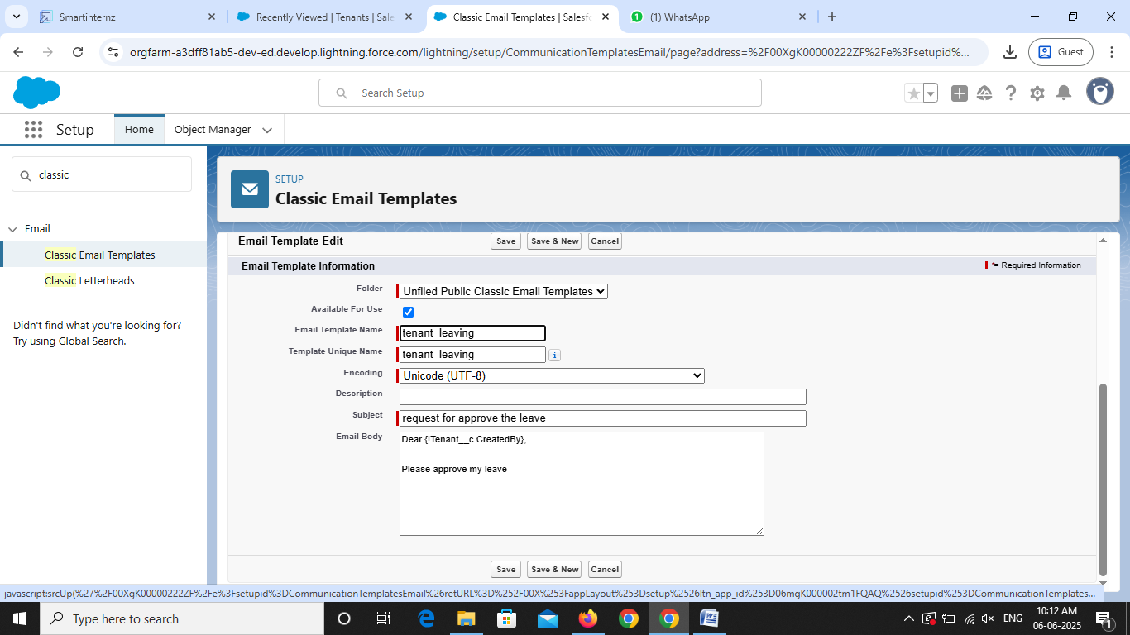

**Activity – 2 Create Email Template for Leave Approved**

To create Email Templates:

From the set up

1. In the quick find box >>Enter Email templates>>Click on classic email template

2. Click on >>New Email

Template===>>Choose Text

Folder: Unified public Classic Email templates

Click on available for use

3. Email Template Name is “Leave approved”

4. Template Unique Name: auto populated

5. Subject: “leave approved”

6. Email body:

Dear {! Tenant__cName.},

I hope this message finds you well. I am writing to inform you that I have received your email confirming the approval of my leave request. I would like to express my gratitude for considering and approving my time off.

your leave is approved. You can leave now

7. Save

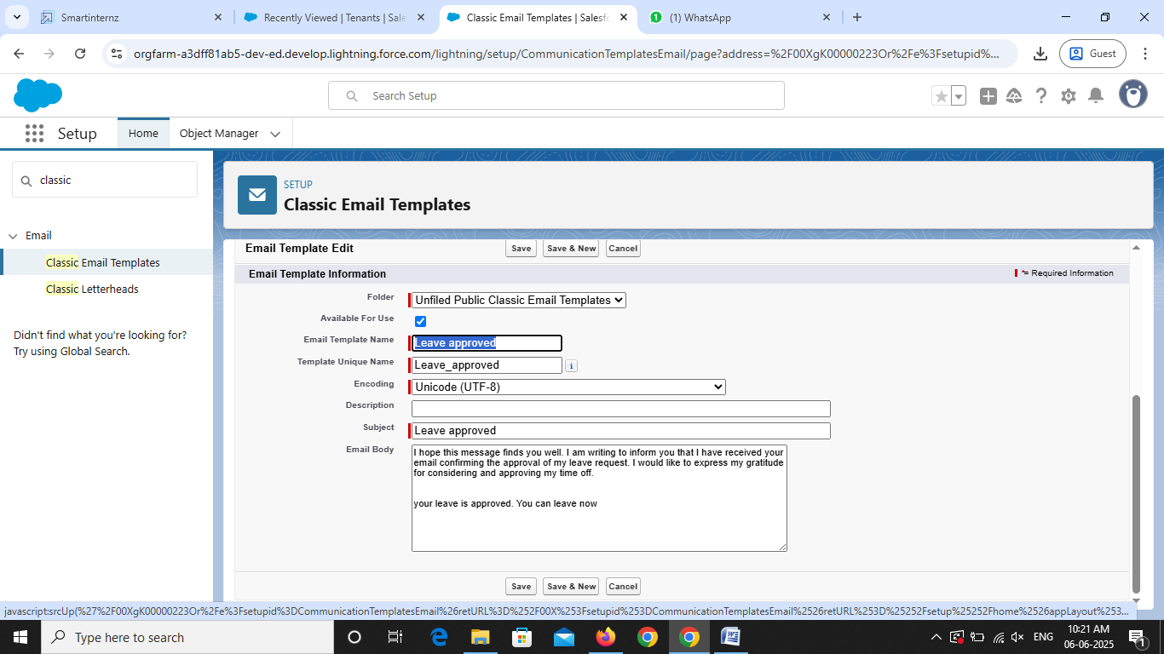

**Activity – 3 Create Email Template For rejection for leave**

To create Email Templates:

From the set up

1. In the quick find box >>Enter Email templates>>Click on classic email template

2. Click on >>New Email

Template===>>Choose Text

Folder: Unified public Classic Email templates

Click on available for use

3. Email Template Name is “Leave rejected”

4. Template Unique Name: auto populated

5. Subject: “Leave rejected”

6. Email body:

Dear {! Tenant__c. Name},

hope this email finds you well. Your contract has not ended. So, we can't approve your leave

your leave has rejected

7. Save

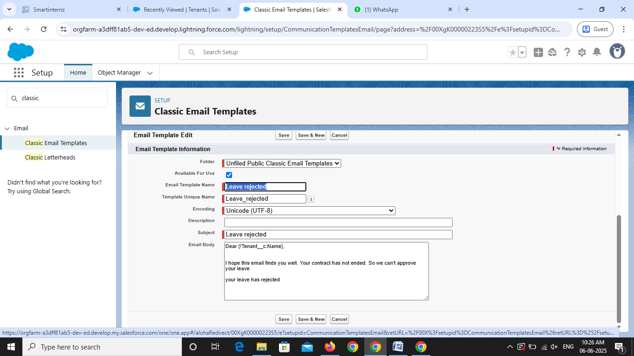

**Activity – 4 Create Email Template For Monthly payment**

To create Email Templates:

From the set up

1. In the quick find box >>Enter Email templates>>Click on classic email template

2. Click on >>New Email

Template===>>Choose Text

Folder: Unified public Classic Email templates

Click on available for use

3. Email Template Name is “Tenant Email”

4. Template Unique Name: auto populated

5. Subject:” Urgent: Monthly Rent Payment Reminder”

6. Email body:

Dear {! Tenant__c. Name},

I trust this email finds you well. We appreciate your continued tenancy at our property and I hope you have been comfortable in your residence.

This communication is a friendly reminder regarding your monthly rent payment, which is currently outstanding. As outlined in our rental agreement, the payment is due . To ensure the smooth operation of our property management and to avoid any inconvenience, we kindly request you to settle the payment at your earliest convenience.

7. Save

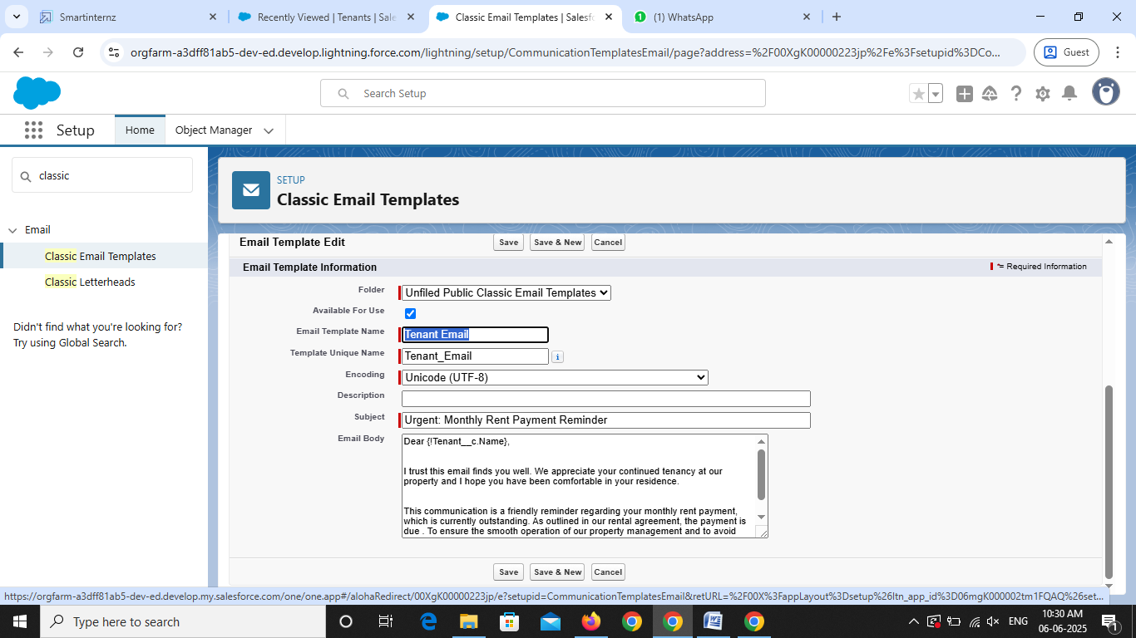

**Activity – 5 Create Email Template For successful payment:**

To create Email Templates:

From the set up

1. In the quick find box >>Enter Email templates>>Click on classic email template

2. Click on >>New Email

Template===>>Choose Text

Folder: Unified public Classic Email templates

Click on available for use

3. Email Template Name is “tenant payment”

4. Template Unique Name: auto populated

5. Subject: “Confirmation of Successful Monthly Payment”

6. Email body:

Dear {! Tenant__c. Email__c},

We hope this email finds you well. We are writing to inform you

that we have successfully received your monthly payment. Thank you for your prompt and diligent payment.

7. Save

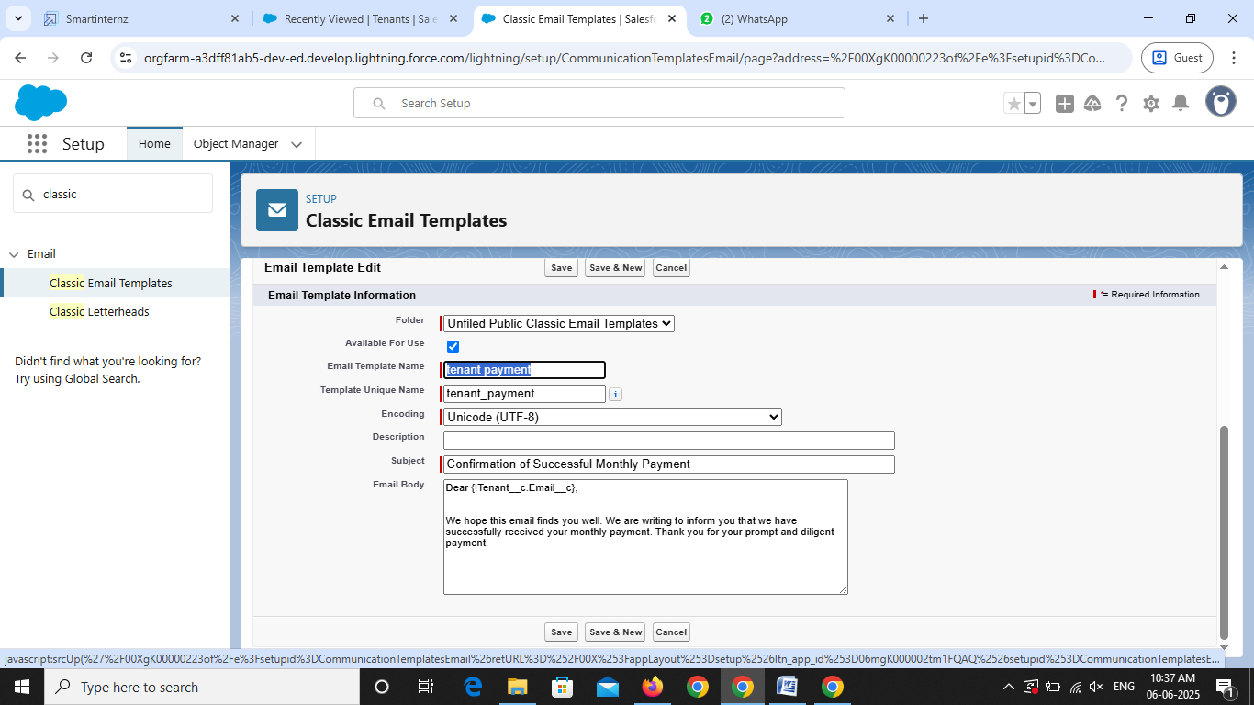

**Milestone – 8**

**Approval Process**

**Activity – 1 Create Approval Process for check for vacant:**

To create fields in an object

From the set up

1. In the quick find box >>Search for Approval process>>Click on it

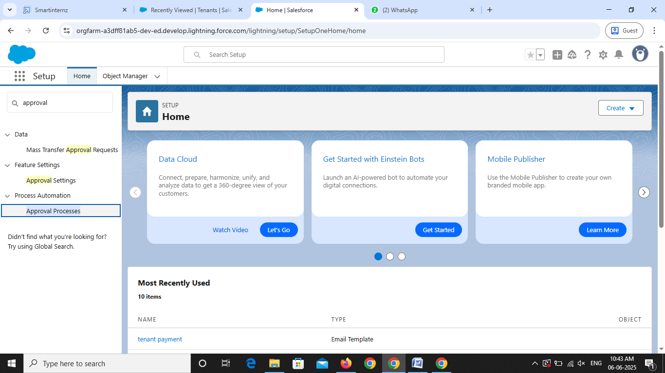

2. Manage approval process for “Tenant” from the drop down

3. Click on “create new approval process”>>use standard set up wizard

4. Process name “check for vacant”>>Click on next

5. Field >>tenant: status>>Operator: Not equals>>value>>Click on the look up filter icon and select “Leaving”

6. Click on insert field, click on next

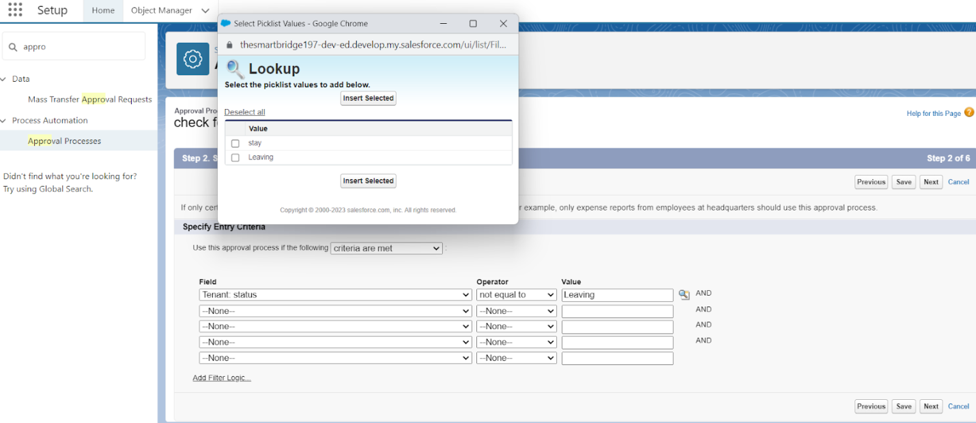

7. Next Automated Approver determined by “None” from the drop down.

8. Select the “Administrators ONLY can edit records during the approval process”.

9. Then click Next.

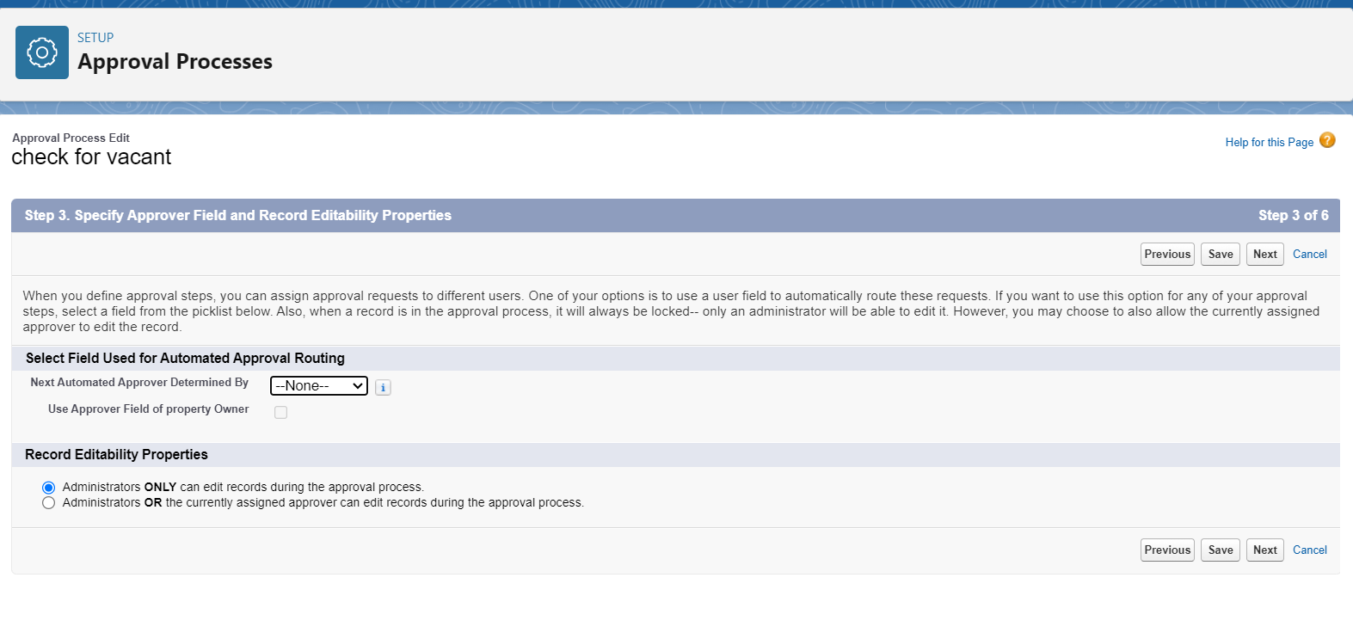

10. From the available fields select >> Tenant Name, and then add >>Add it to the selected. Then Next

Make sure Display approver history is checked.

 And under security settings check the “Allow approvers to access the approval page only from within the Salesforce application. (Recommended)” option.

11. Submitter type Search>>Owner, Allowed Submitters>>Property Owner. Then Next. 12. Then click save.

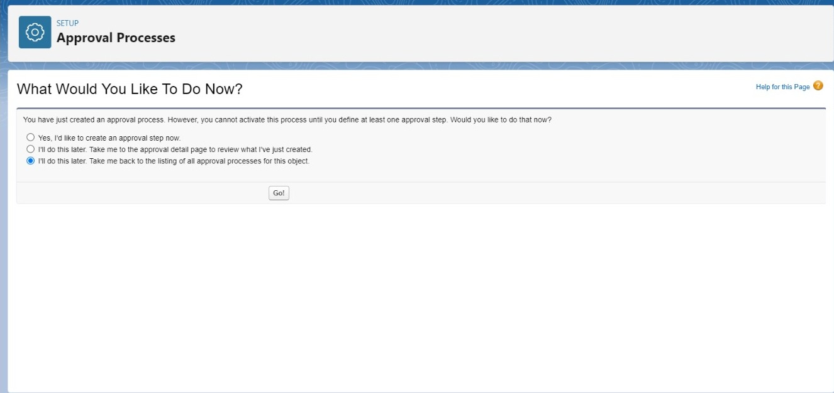

* Click on “I’ll do this later. Take me back to the listing of all approval process for this object
* Click go

**Activity – 2 Initial Submission Action:**

1. Under initial submission action click on add new and then select email alert.

2. Description: “please approve my leave”

3. unique name: auto populated

4. Email template: tenant leaving

5. Recipient type: Email field

6. Available Recipients: Email field: Email

7. From Email address: Current user’s email

8. Click save.

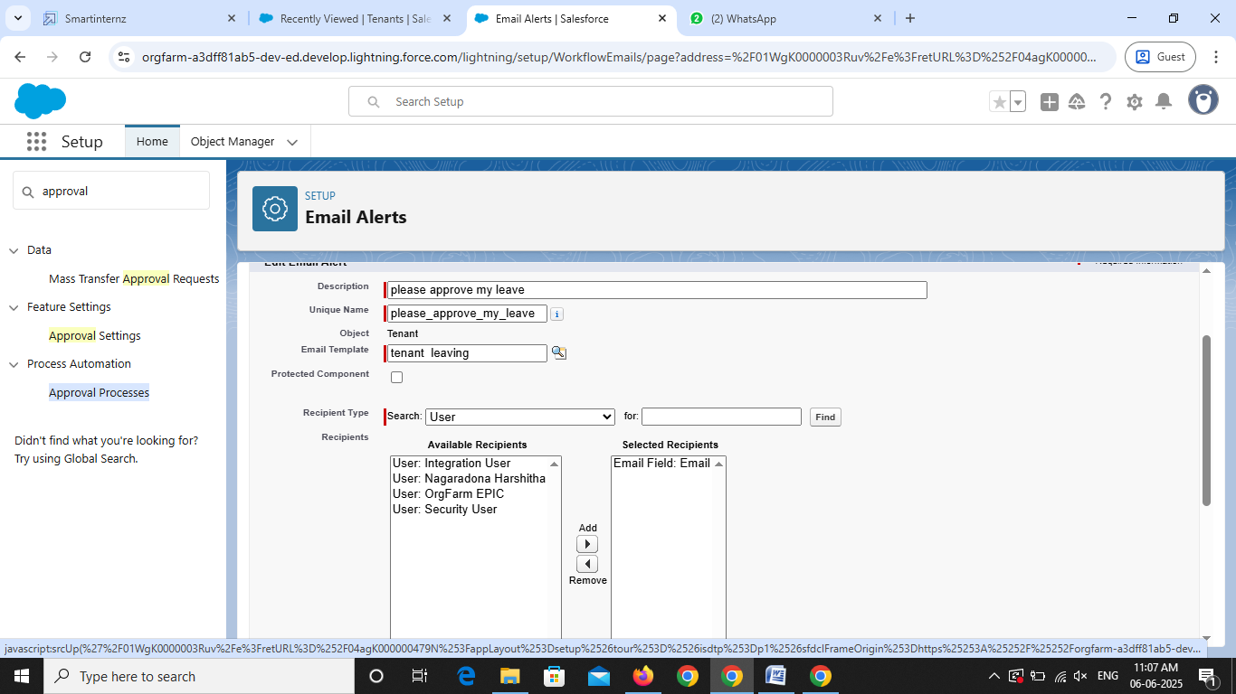

**Activity – 3 Final Approval Action:**

1. Under Final approval action click on new and then select email alert.

2. Description: “Tenant leaving”.

3. unique name: auto populated

4. Email template: Leave approved

5. Recipient type: Email field

6. Available Recipients: Email field: Email

7. From Email address: Current user’s email

8. Click save.

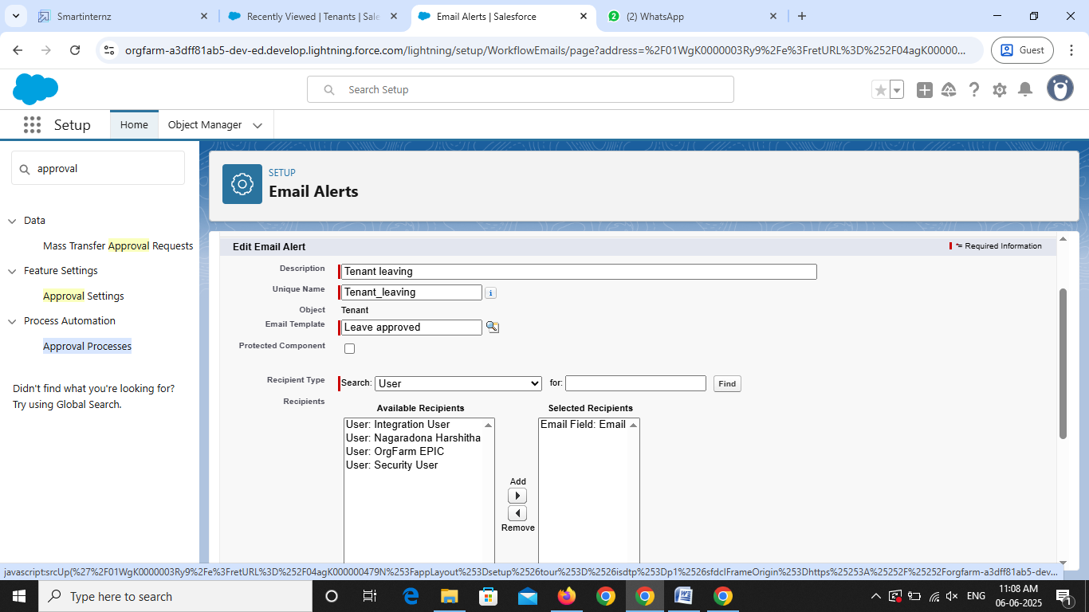

**Activity – 4 Final Rejection Action:**

1. Under Final rejection action click on new and then select email alert.

2. Description: “Your request for leave is rejected”.

3. unique name: auto populated

4. Email template: leave rejected

5. Recipient type: Email field

6. Available Recipients: Email field: Email

7. From Email address: Current user’s email

8. Click save.

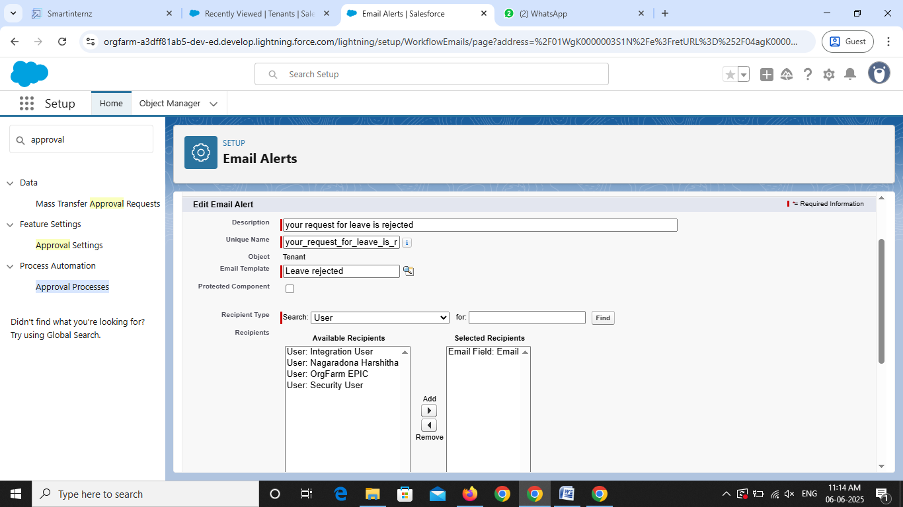

**Milestone – 9**

**Apex Trigger**

**Activity – 1 Create an Apex Trigger:**

To create a new Apex Trigger, follow the below steps

1. Click on file>>New>> Apex Trigger

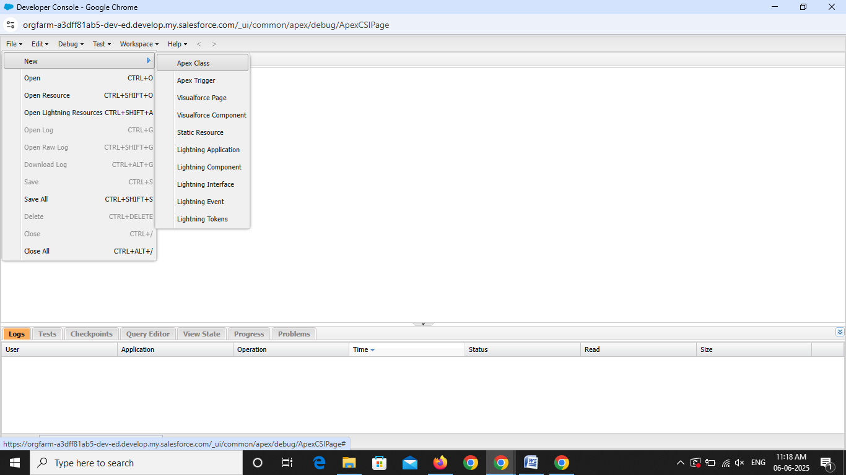

1. Give the Apex trigger name as Test>>select Tenent__c from the drop down sObject

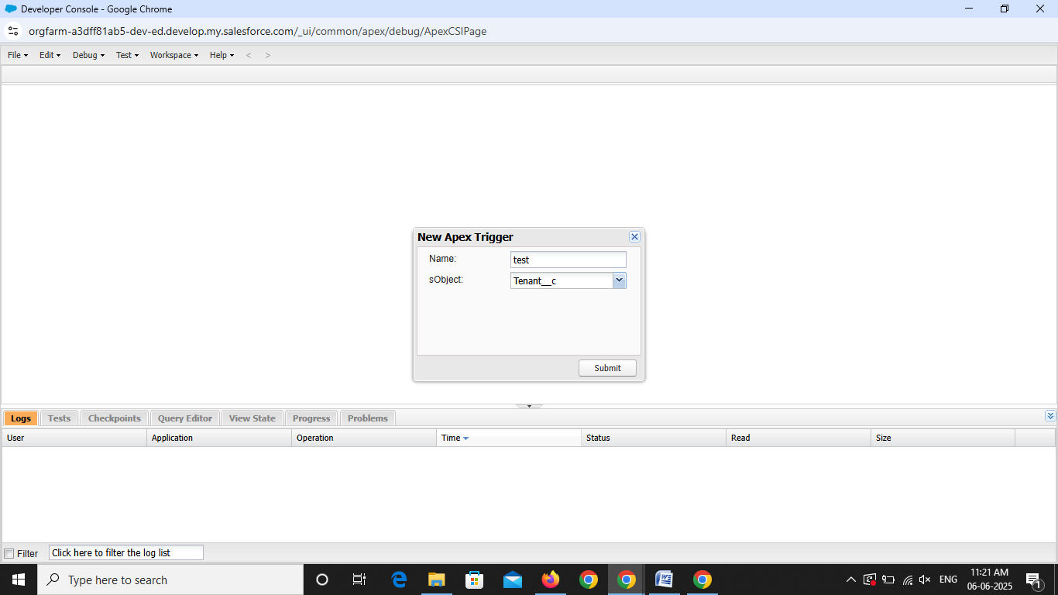

3. Click on submit

4. Now write the code logic here

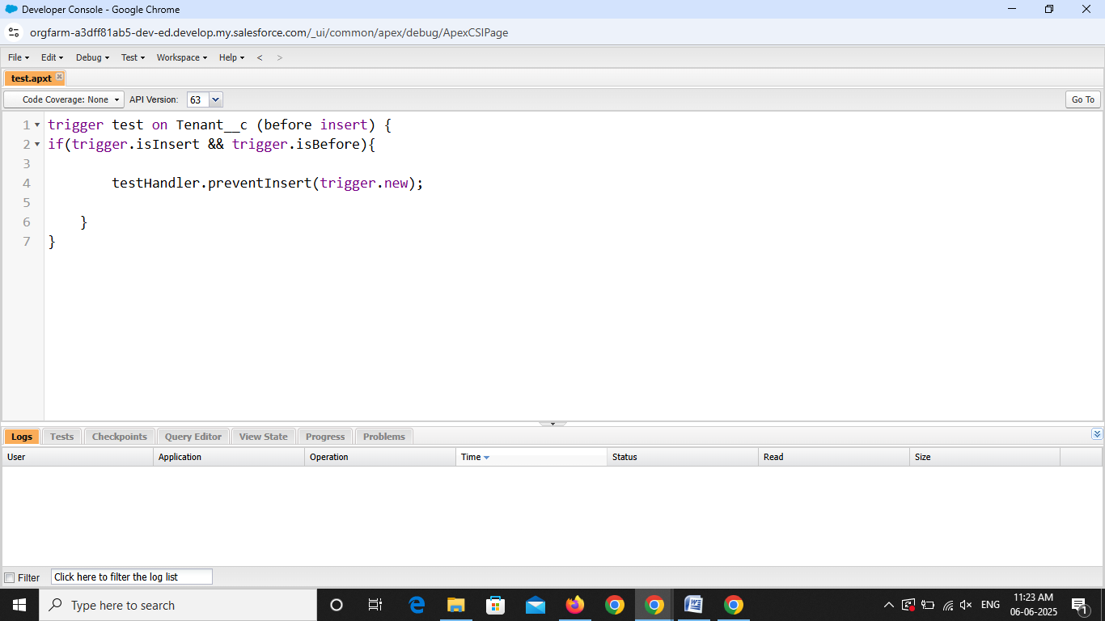

Trigger Code:

trigger test on Tenant__c (before insert)

{

    if (trigger. is Insert && trigger.isBefore){

        testHandler.preventInsert(trigger.new);

    }

}

5.Click on Save

Create an Apex Handler class:

**To create a new Apex class follow the below steps**

1. Click on file>>New>> Apex class

2. Enter the trigger name as testHandler

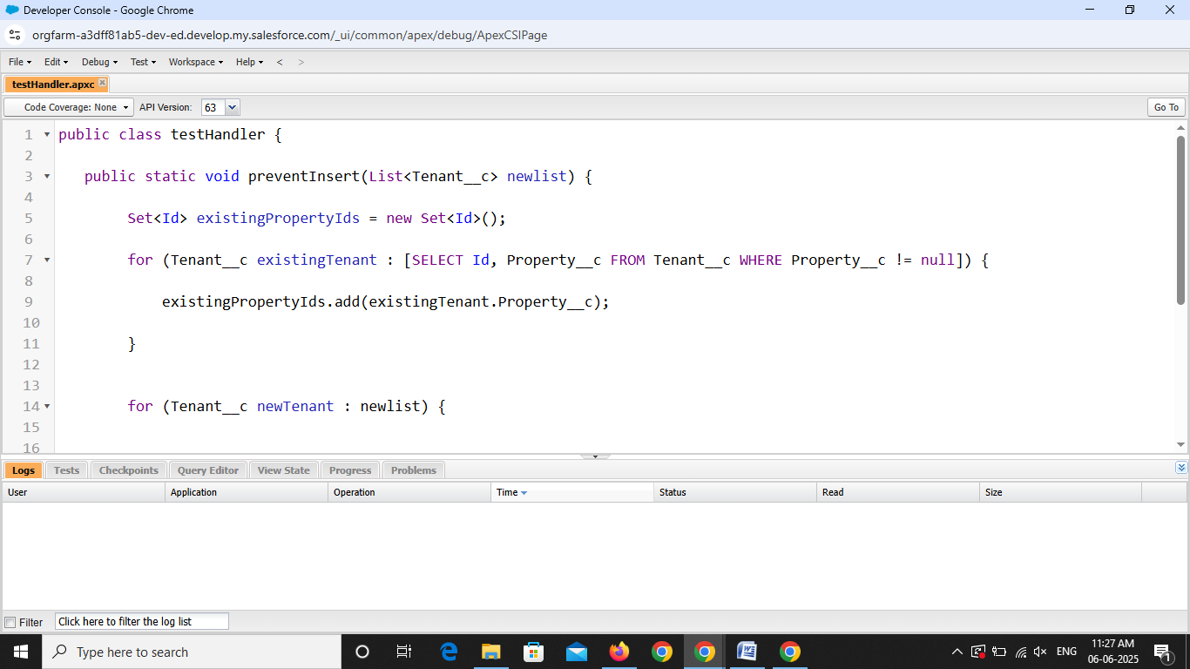

Apex logic:

public class testHandler {

   public static void preventInsert(List<Tenant__c> newlist) {

        Set<Id> existingPropertyIds = new Set<Id>();

        for (Tenant__c existingTenant : [SELECT Id, Property__c FROM Tenant__c WHERE Property__c != null]) {

            existingPropertyIds.add(existingTenant.Property__c);

        }

 for (Tenant__c newTenant : newlist) {

                if (newTenant.Property__c != null && existingPropertyIds.contains(newTenant.Property__c)) {

                newTenant.addError('A tenant can have only one property');

            }

        }

    }

}

1. Click on Save

**Activity – 3 Testing the Trigger:**

Go to AppLauncher search for Lease Management>>Select Tenant>>

Try to create new tenant with the existing property

1. Go to AppLauncher search for Lease Management>>Select Tenant>>Click on New

2. Enter the details of User

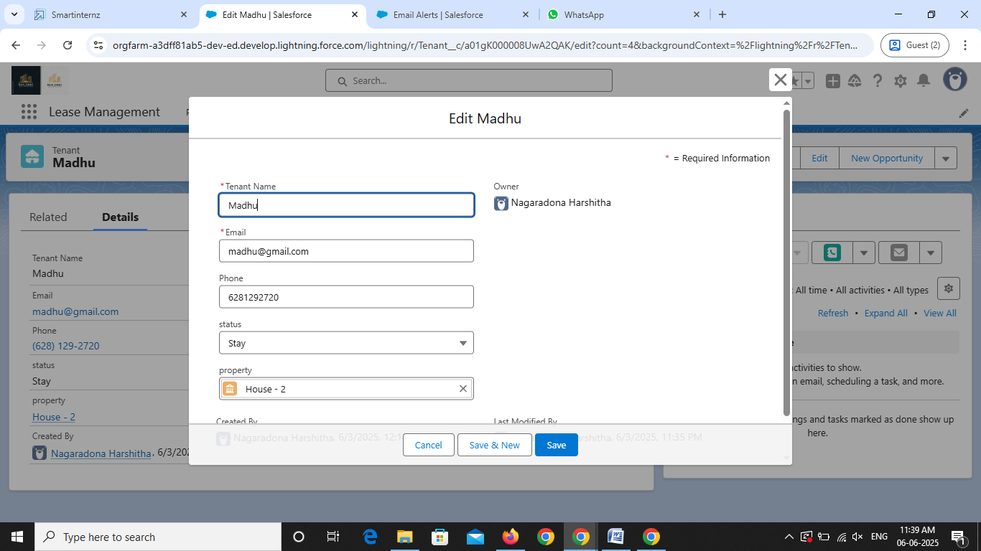

3. Select property as House-2

4. Click on Save

**Milestone – 10**

**Flows**

**Activity – 1 Create Flow for monthly payment**

1. Go to setup >> type Flow in quick find box >> Click on the Flow and Select the New Flow.
2. Select the record Triggered flow. Click on create.

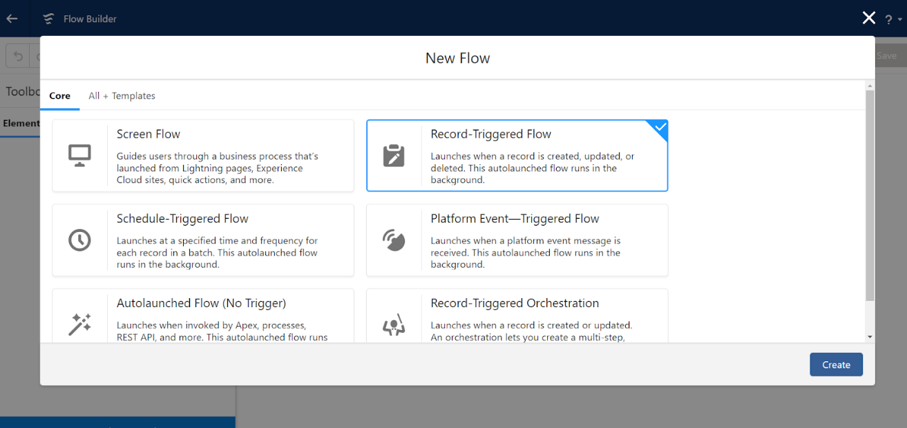

1. Under Object select” Payment for tenant”. Click on A record is updated.

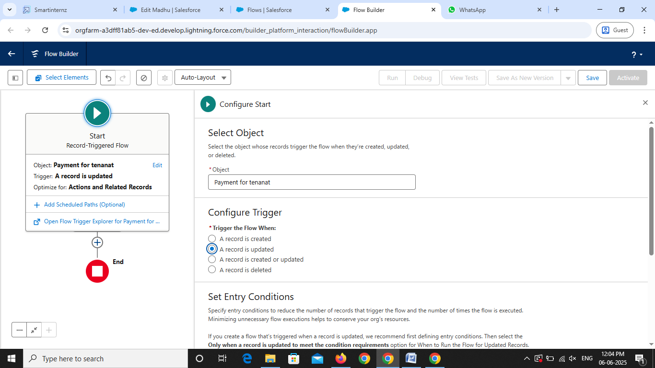

Set Entry Conditions  
 Under Condition Requirements  
 All Conditions are met

Field: check_for_payment__c operator: Equals value: Paid

5. Click on: Every time a record is updated and meets the condition requirements

6. Click on: Actions and related records, done

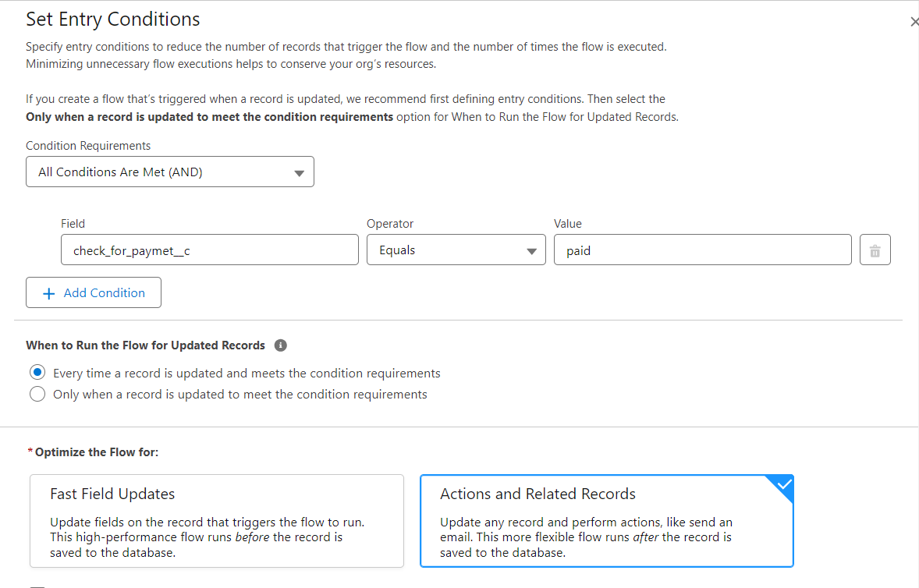7. Under record trigger flow click on “+” icon and select action  
  
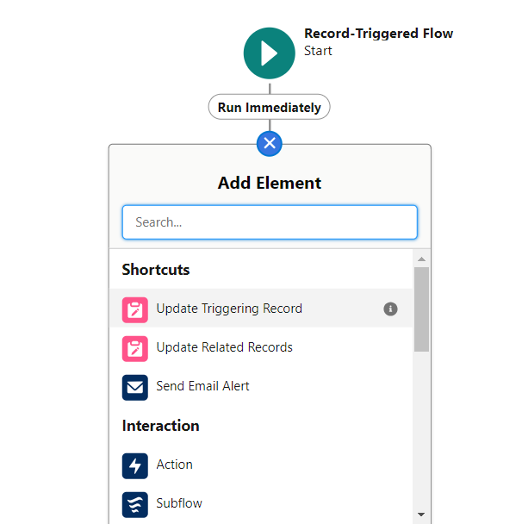

7. In action search for send email then click on send email (check below image)

8. Label: send email

9.API Name: send email

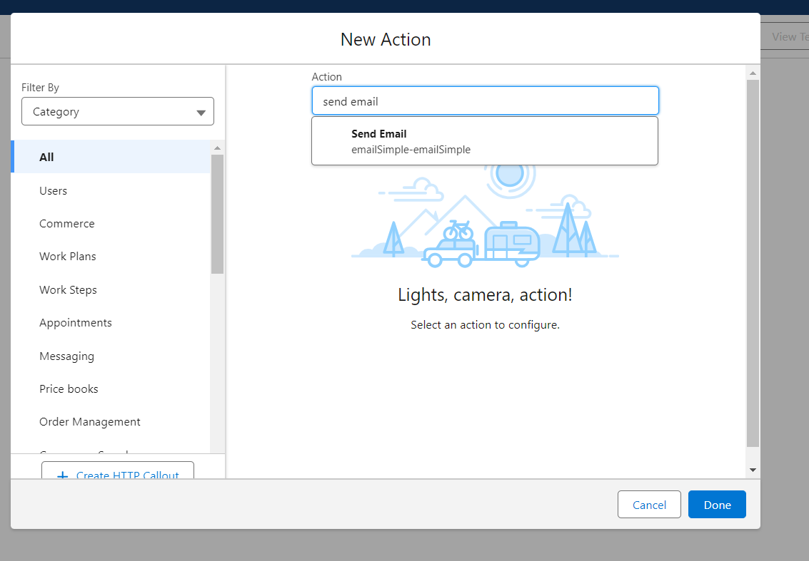

10. Enable Body  
11. Click on new resource

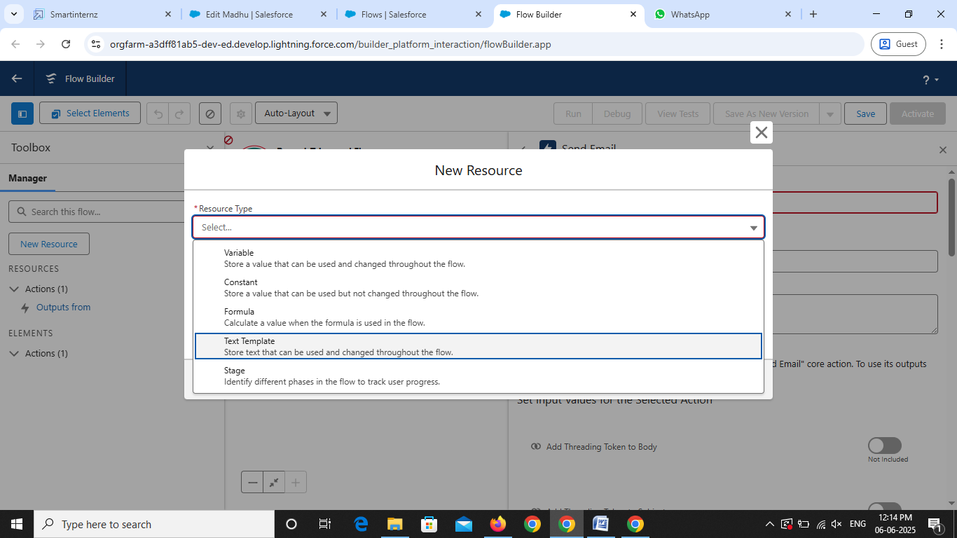

Under resource type select “Text Template”  
API Name : emailbody  
Under body:(paste the below text)  
Dear {! $Record.Tenant__r. Name},

We hope this email finds you well. We are writing to inform you that we have successfully received your monthly payment. Thank you for your prompt and diligent payment.

12. Click Done.  
13. Enable recipient Address List  
 Paste this? {! $Record.Tenant__r. Email__c}  
14. Click Done  
15. Enable subject  
 Paste this >> Confirmation of Successful Monthly Payment  
16. Click on save  
 Flow label: monthly payment  
 Flow API Name: monthly payment

Click on activate

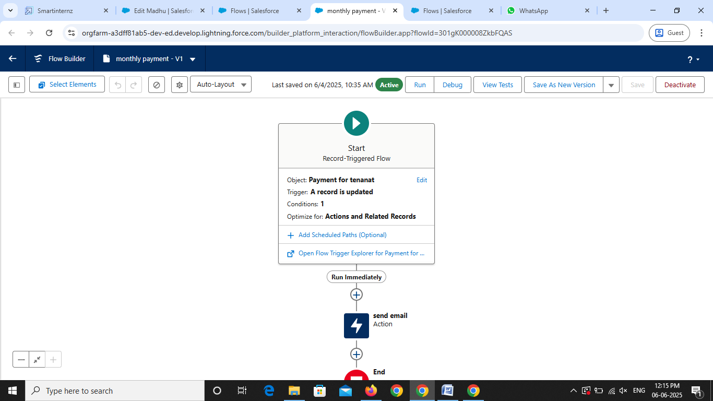

**Milestone – 11**

**Schedule class**

**Create an Apex Class**

To create a new Apex Class, follow the below steps:

1.Click on the file >> New >> Apex Class.

2.Enter class name as MonthlyEmailScheduler.

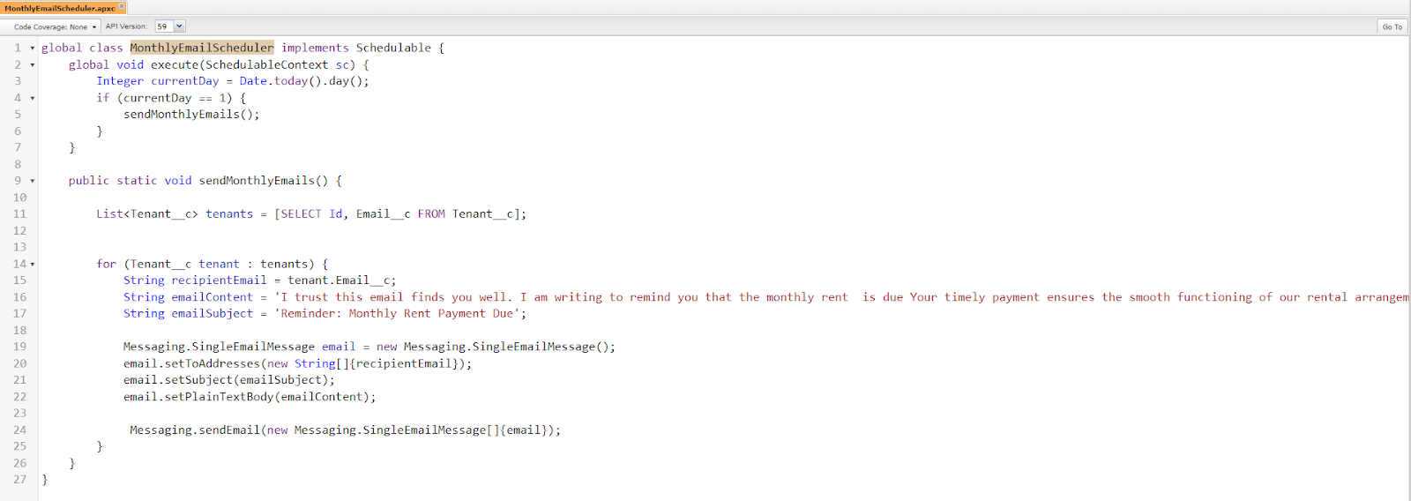

Apex logic:

global class MonthlyEmailScheduler implements Schedulable {

    global void execute(SchedulableContext sc) {

        Integer currentDay = Date.today().day();

        if (currentDay == 1) {

            sendMonthlyEmails();

        }

    }

 public static void sendMonthlyEmails() {

        List<Tenant__c> tenants = [SELECT Id, Email__c FROM Tenant__c];

        for (Tenant__c tenant : tenants) {

            String recipientEmail = tenant.Email__c;

            String emailContent = 'I trust this email finds you well. I am writing to remind you that the monthly rent  is due Your timely payment ensures the smooth functioning of our rental arrangement and helps maintain a positive living environment for all.';

            String emailSubject = 'Reminder: Monthly Rent Payment Due';

            Messaging.SingleEmailMessage email = new Messaging.SingleEmailMessage();

            email.setToAddresses(new String[]{recipientEmail});

            email.setSubject(emailSubject);

            email.setPlainTextBody(emailContent);

             Messaging.sendEmail(new Messaging.SingleEmailMessage[]{email});

        }

    }

}

3. Save the code

**Activity – 2 Schedule Apex class:**

1. Enter Apex class in quick find box

2. Select schedule Apex

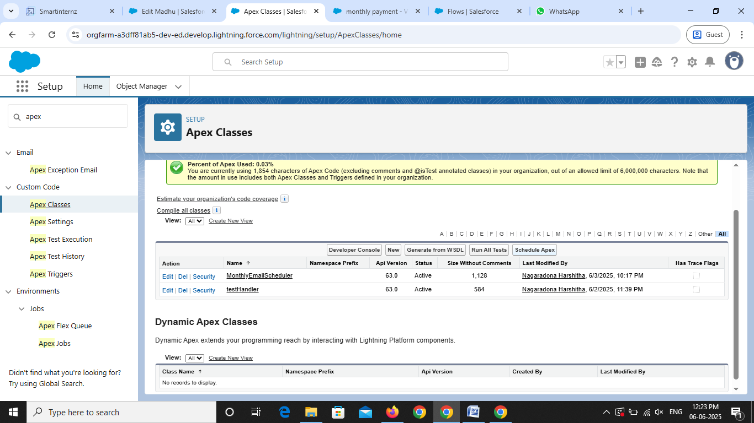

3. Enter job Name: MonthlyEmailScheduler

4. Apex class: MonthlyEmailScheduler

5. Frequency: Monthly===>select on day 1

6. Start date: 04/12/2023

7. End date: 04/01/2024

8. Preferred start time: 09:00 am

9. save

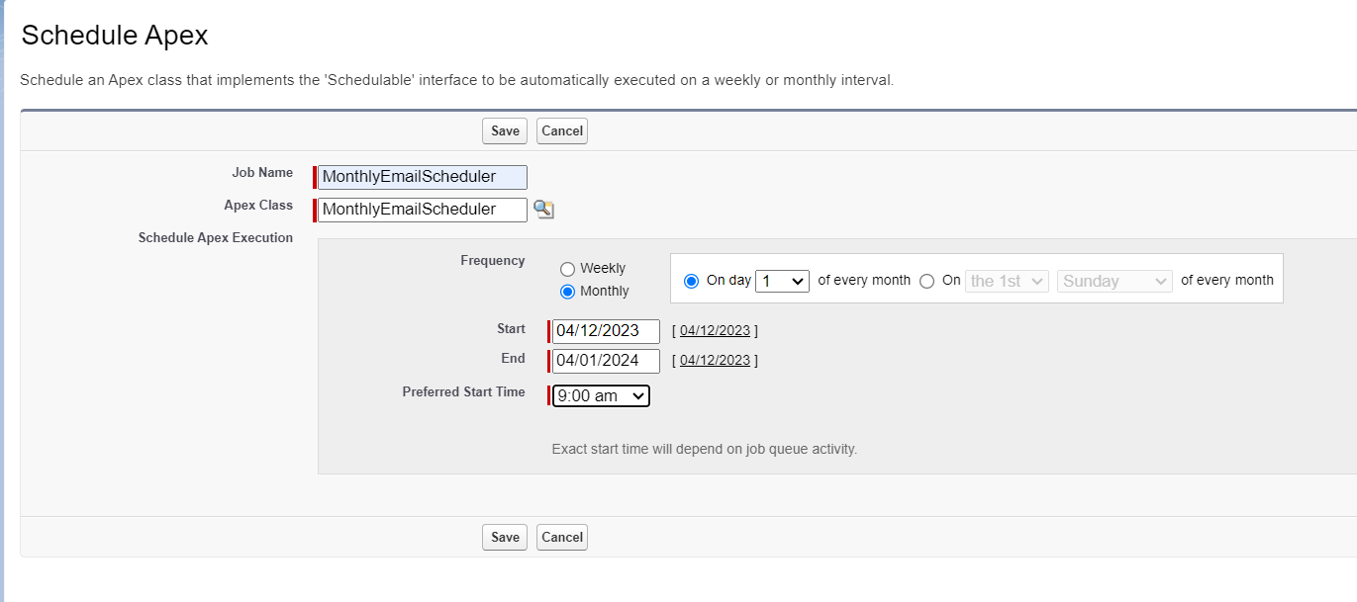

From the set up

1.Go to ObjectManager>>Select tenant>>Click on page layouts

2.Go to the buttons tab

3.Drag submit for approval towards the tenant detail

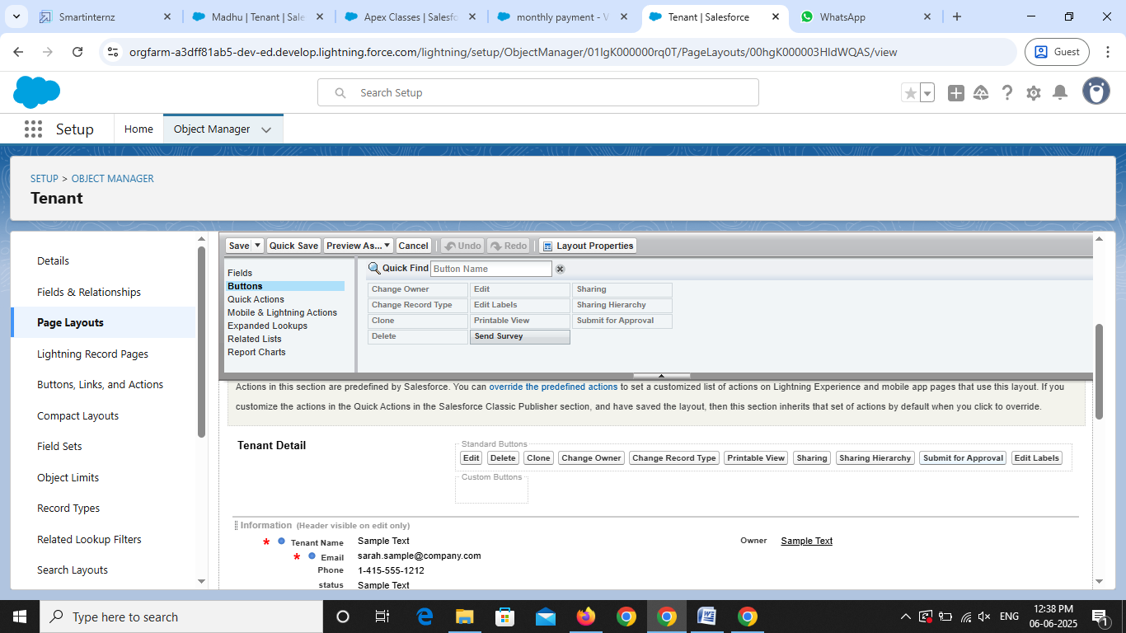

1.Go to AppLauncher>>Search Lease Management>>Select Tenant

2.Click on the user created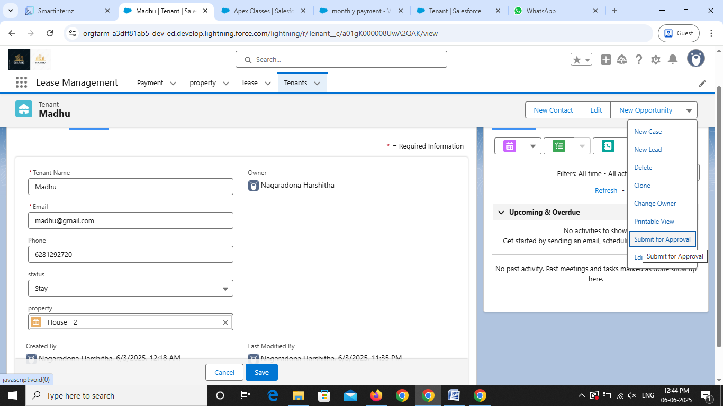

3.Enter any comment am\nd click on submit

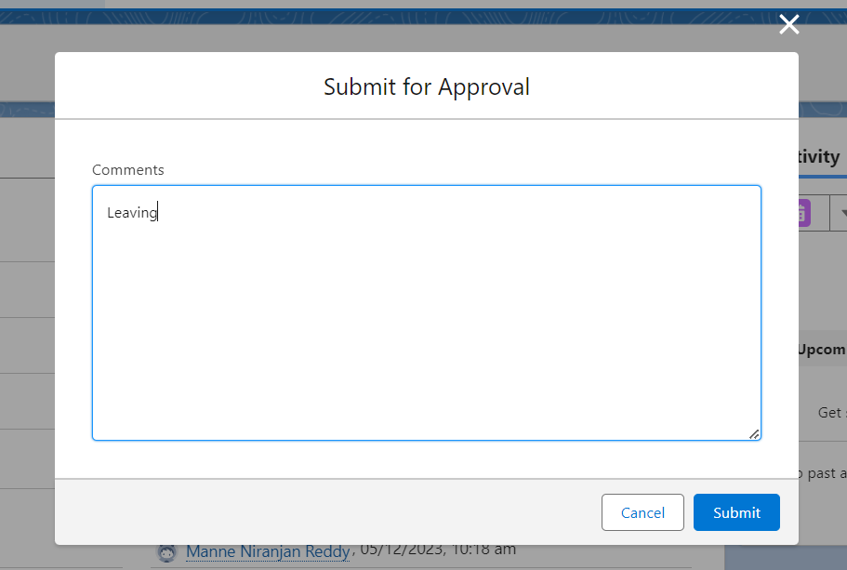

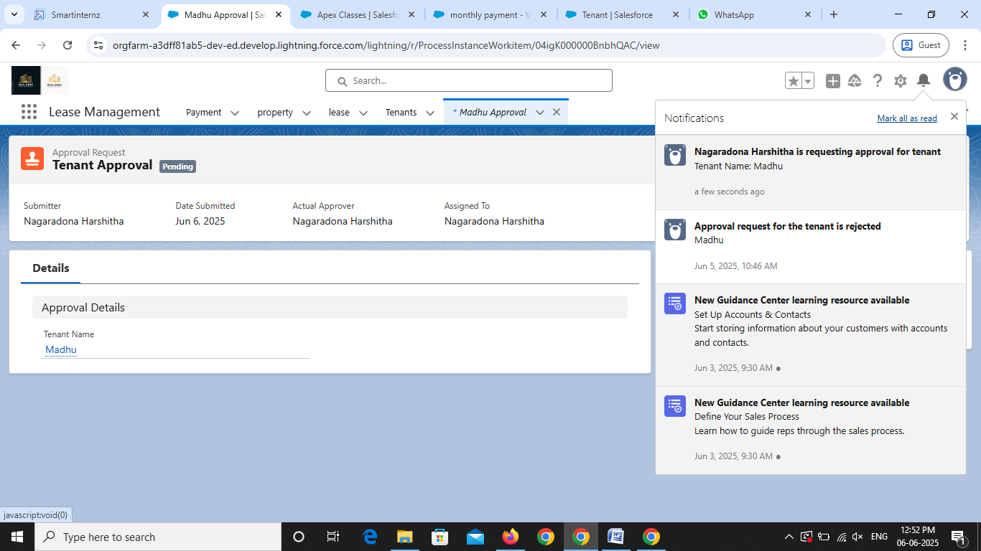

Click on that notification

click on approve

Give any comment and submit

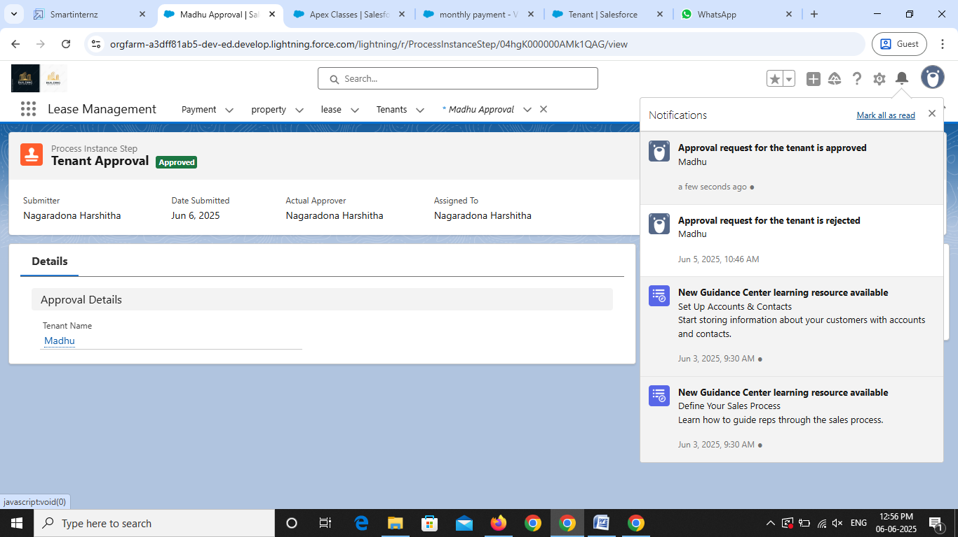

You will find notification like this and you will get an email check

**Testing the Reject process**

Enter any comment am\nd click on submit

Click on that notification

Click on reject

Give any comment and submit

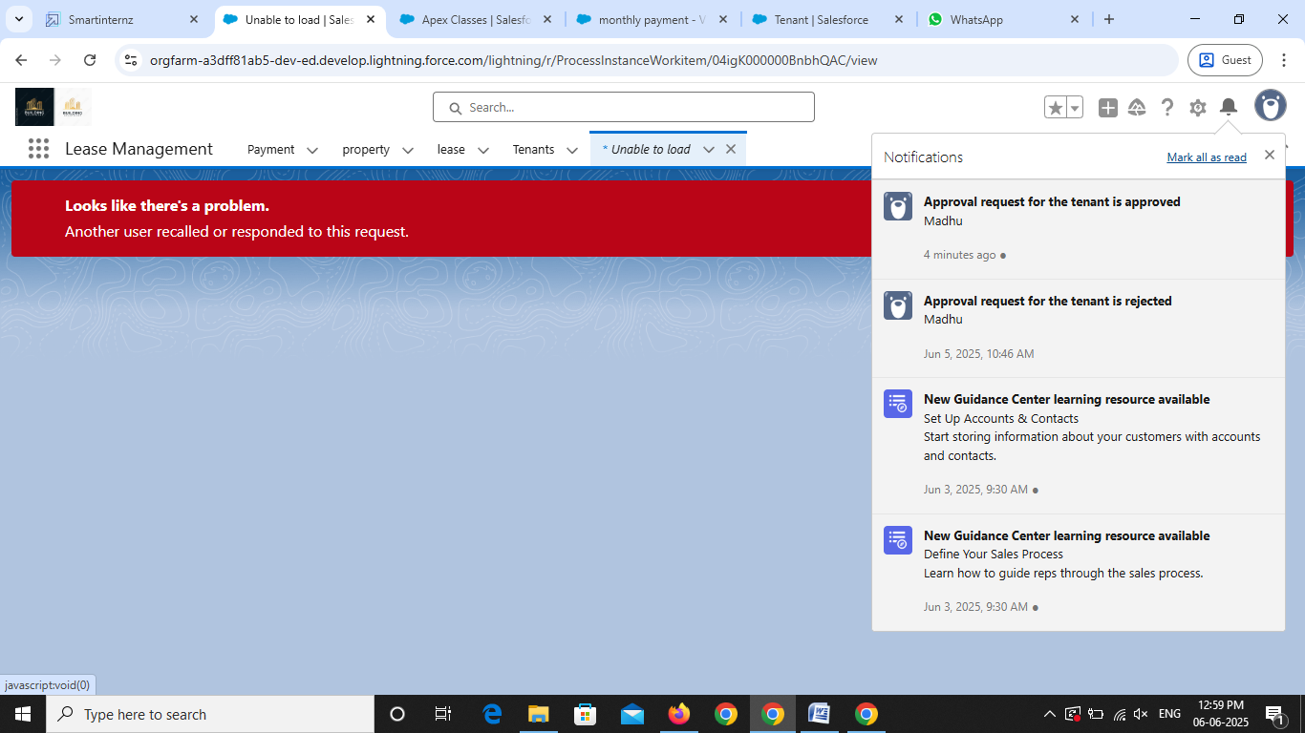

You will find notification like this and you will get an email check

### 